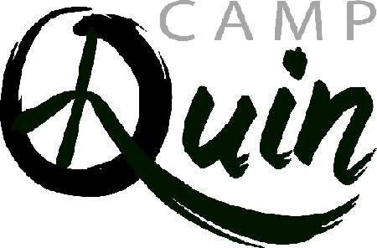

**Mail to:**

Camp Quin

c/o Camp Directors

P.O. Box 277

Palmyra, NY 14522

Camp dates are:

**June 27 – July 2**

Email: camp@camp-quin.com

Web: camp-quin.com

**2021 Camper Registration Form**

**Camper Information**

Name: Nickname: Last Name: Gender: Birth Date: Grade Entering: ____________________

Tell us how you heard about Camp Quin?___________________________________________________________

**Parent/Guardian/Caregiver Information**:

Parent 1-First Name: Last Name:

Relationship to Camper:

Telephone: Email:

Address:

City: State: Zip:

Parent 2-First Name: Last Name:

Relationship to Camper:

Telephone: Email:

Address:

City: State: Zip:

**Emergency Contact Information**

Emergency Contact 1 – First Name: Last Name:

Telephone: Relationship to Camper:

Emergency Contact 2 – Frist Name: Last Name:

Telephone: Relationship to Camper:

**Programs at Camp Quin**

Campers need to choose one (1) major and two (2) minor programs they would like to take. Under the Major program, put a “1” by your first choice and a “2” by your second choice. Under each of the Minor Programs place a “1” by your first choice and a “2” by your second choice.

**Each of the 3 programs MUST have a 1st and 2nd choice option.**

|  |  |  |
| --- | --- | --- |
| **MAJORS** | **MINOR 1** | **MINOR 2** |
| **_____ Improv/Storytelling** | **_____ Nature of Us** | **_____ Improv/Storytelling** |
| **_____ Visual Arts** | **_____ Fire & Food** | **_____ Visual Arts** |
| **_____ Words & Music** | **_____ Kayaking (must be proficient in swimming)** | **_____ Words & Music** |
| **_____ Yoga** | **_____ Camp Fire Building** | **_____ Yoga** |

**Additional Information**

Do you want **VEGETARIAN** Meals ______ Yes ______ No

Other **SPECIAL NEEDS** (dietary or medical) __________________________________________________________

Deposit & Payments: The cost for camp is $300.00, and a $50.00 deposit must be included with this registration form. The remaining $250.00 will be due June 20. Payments can be made by check payable to:

Camp Quinn, c/o Camp Directors, P.O. Box 277, Palmyra, NY 14522

Scholarships: Through fundraising and grants awarded to Camp Quin there is a small of amount of tuition assistance available to campers. Please fill out the scholarship form found on the web page and submit with your registration deposit.

Refund Policy: Deposits are refundable until June 1st.

Waiver/Statement of Parent: In signing this application, I hereby certify that the information provided is accurate. I recognize there is an element of risk in any adventure, sport or activity associated with the outdoors. I have read and understand the payment, refund early dismissal policies.

*Please answer yes or no on each below item:*

* The camper may participate in swimming and boating activities with a counselor and lifeguard present in the pool and boating area. Yes _____ No _____
* The camper may be photographed and/or appear in a video, or written media to be used for publicity purposes, newspapers, radio internet, TV, etc. Yes _____ No _____

Print Name of Parent/Guardian/Caregiver:

Relationship to Camper:

Camper Signature: _____________________________________________________________________________